OZL Ozone Sensor Specs (Low Range):
Sensor Code | OZL
Range | 0-0.5 ppm
Sensor Type | GSS
Minimum Detection Limit | 0.001 ppm
Accuracy of Factory Calibration | <±0.008 ppm 0-0.1 ppm  <±10% 0.1-0.5 ppm
Resolution | 0.001 ppm
Response Time | 60 Seconds
Temp | 0 to 40°C
Relative Humidity | 10 to 90%

OZL Sensor Cross-Sensitivity
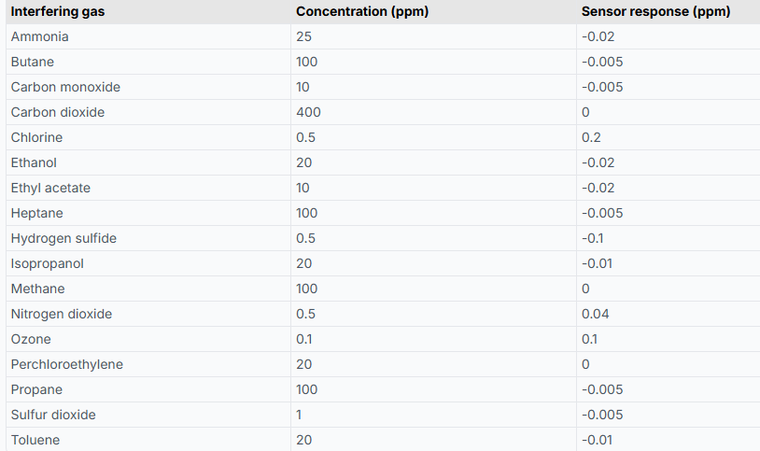

EOZ Sensor specs shown on next page

EOZ Sensor Specs (High Range):
Sensor Code | EOZ
Range | 0-10 ppm
Sensor Type | GSE
Minimum Detection Limit | 0.01 ppm
Accuracy of Factory Calibration | <±0.01 ppm + 7.5%
Resolution | 0.01 ppm
Response Time | 60 Seconds
Temp | 0 to 40°C
Relative Humidity | 15 to 90%

