Visual Inspection | Yes | No
Gaskets ripped or worn?
Adapter pieces cracked or broken?

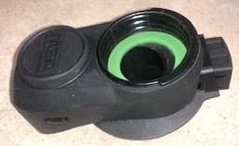Facepiece Adapter (P-100 Side) | 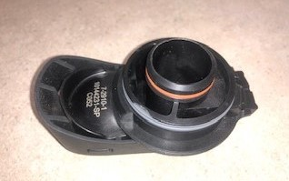Facepiece Adapter (Mask Side) | 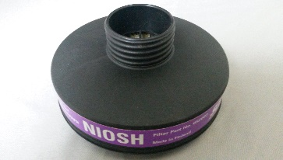  P-100 Filter
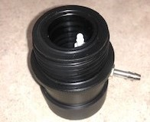  Threaded Adapter (Mask Side) | 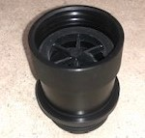  Threaded Adapter (P-100 Side) | 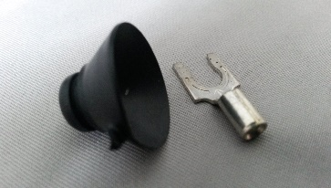  Suction Cup and Clip
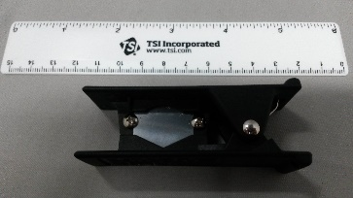  6 Inch Ruler and Cutting Tool | 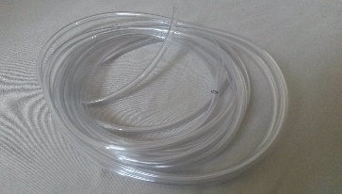  Tubing | 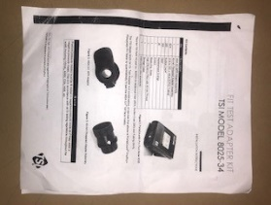  Adapter Kit Instructions

Setup | Y | N
Tubing clean?
Suction cups and clips clean?
P-100 Filters clean?
Used tube pieces removed from case?
Adapter pieces disassembled?

What’s In the Box?
An Inspection Guide to the RAECO Rents Instrumentation You Requested.
The contents of your rental kit will contain all the components shown on this sheet. When you unpack the instrument, please try turning it on. If nothing happens, or a kit component is missing, please call (866)-736-8347 immediately so we can correct the problem.

Functional Inspection | Yes | No
All parts fit together properly?
Cutting tool sharp enough to cut tubing?
P-100 Filters clean?

Included Parts & Accessories | Yes | No
MSA G1 Facepiece Adapter
Threaded Adapter
P-100 Filter
Suction Cups and Clips (Minimum 25 Pieces Included)
Tubing (10ft Minimum)
6 Inch Ruler
Tube Cutting Tool
Adapter Kit Instructions
Carrying Case

Additional Parts or Customer Setup Requests | Yes | No
Extra suction cups and clips Qty: ______

Compatible Respirator Models
MSA G1
Not Shown: Carrying Case

