Visual Inspection | Yes | No
Drink Tube Extensions, ok?
Adapter pieces cracked or broken?

AVON Drink Tube Adapter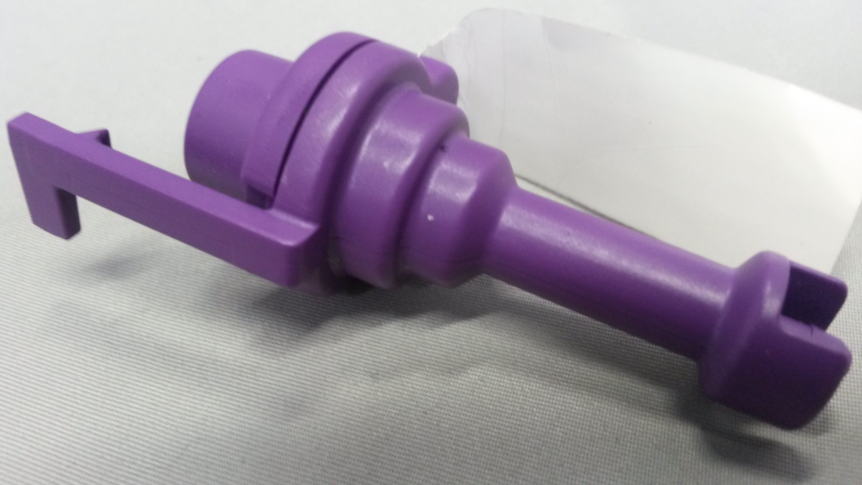 | 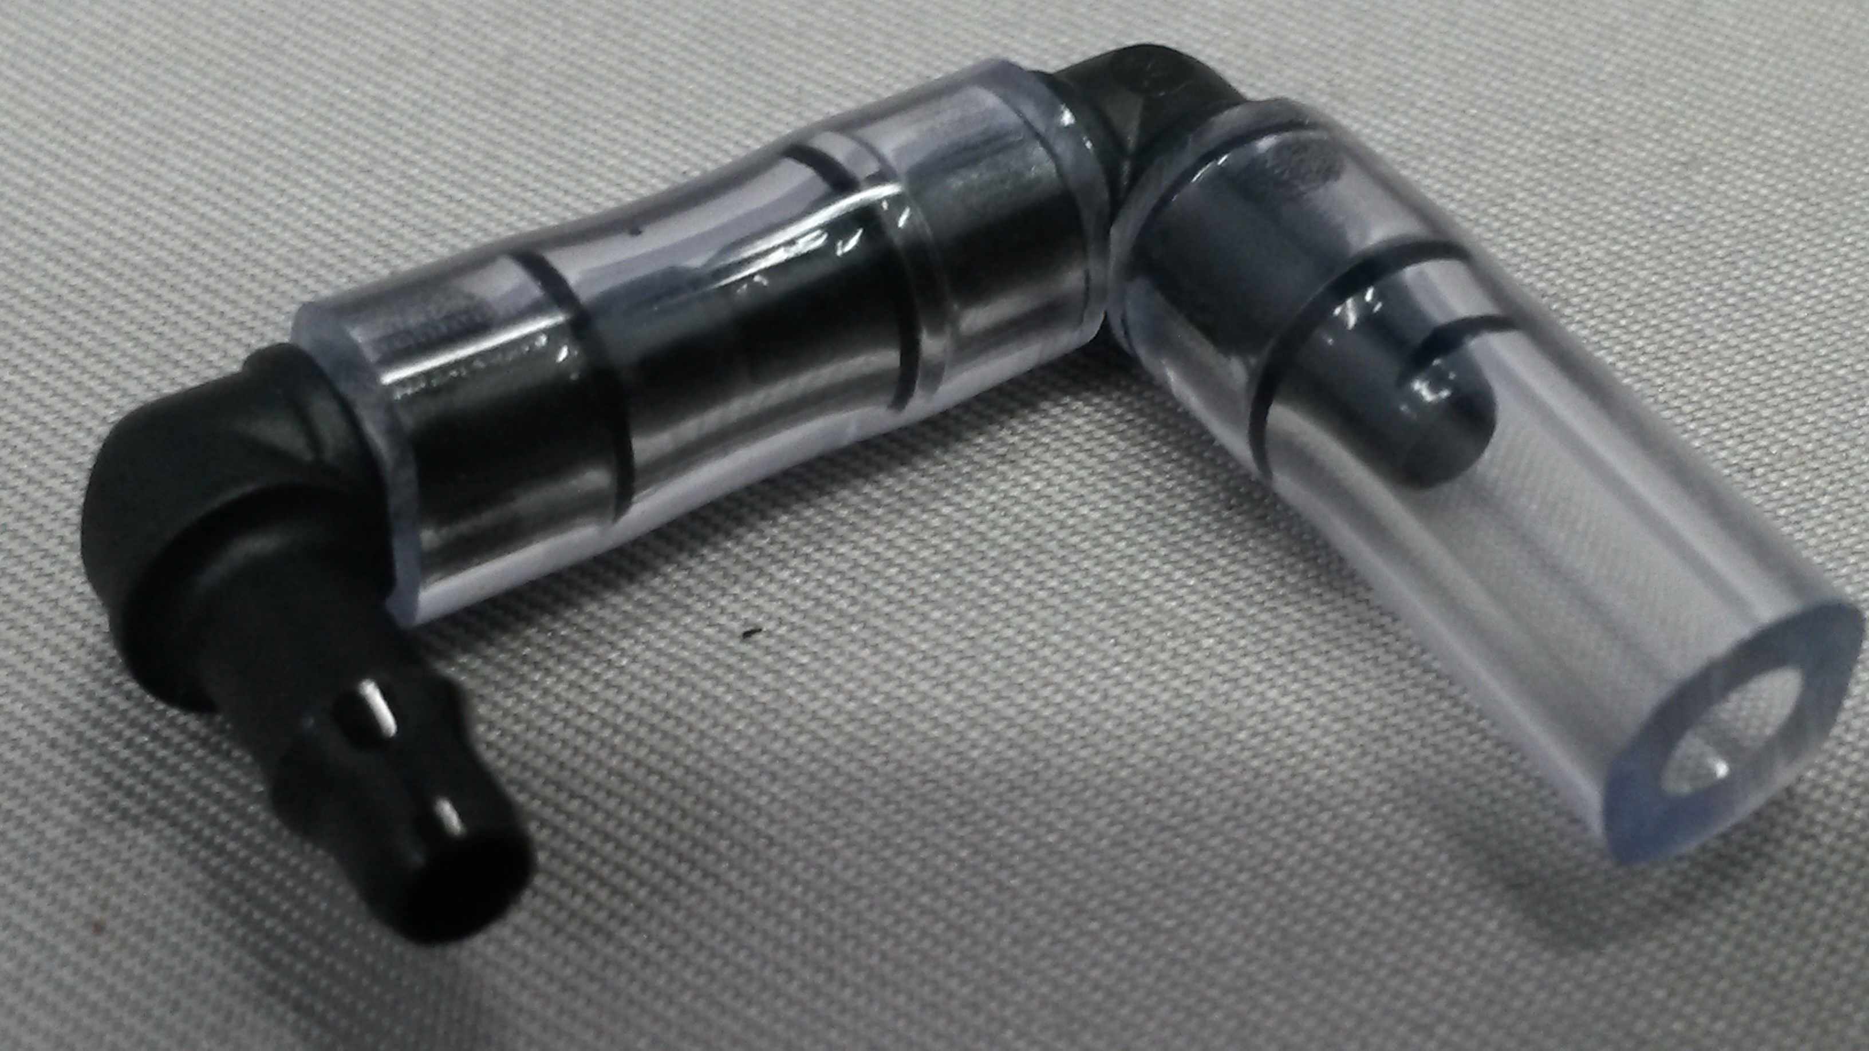Drink Tube Extensions | 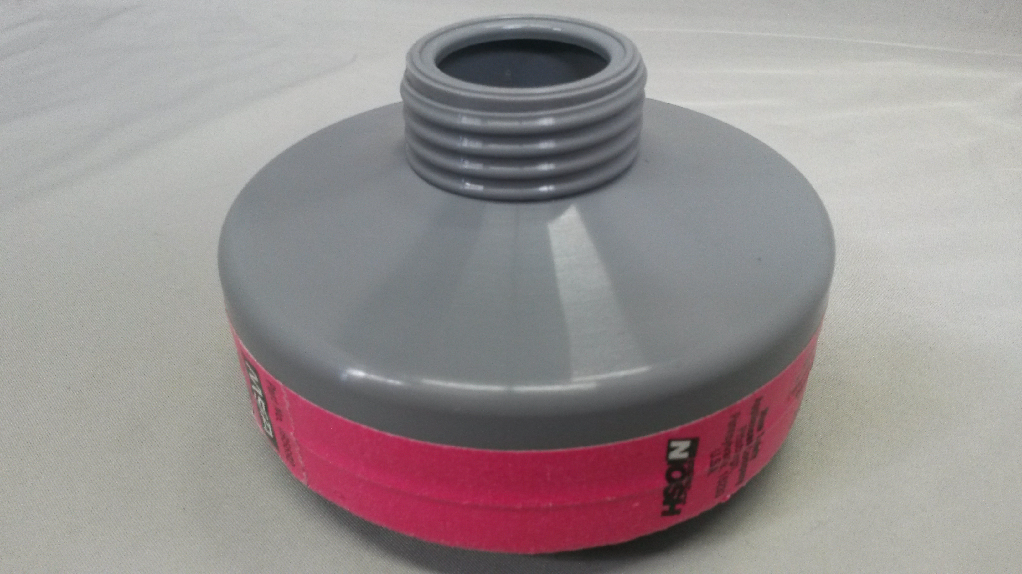P-100 Filter

Setup | Y | N
Drink Tube Adapters Replaced?
Drink Tube Extensions Assembled?
P-100 Filter replaced?
Used tube pieces removed from case?
Adapter pieces disassembled?

Functional Inspection | Yes | No
All parts fit together properly?
Drink Tube Adapters clean?
P-100 Filters clean?
What’s In the Box?
An Inspection Guide to the RAECO Rents Instrumentation You Requested.
The contents of your rental kit will contain all the components shown on this sheet. When you unpack the instrument, please try turning it on. If nothing happens, or a kit component is missing, please call (866)-736-8347 immediately so we can correct the problem.

Included Parts & Accessories | Yes | No
AVON Drink Tube Adapter
Drink Tube Extension (Minimum 25 Pieces Included)
P-100 Filter
Adapter Kit Instructions
Carrying Case

Additional Parts or Customer Setup Requests | Yes | No
Extra Drink Tube Extensions Qty:______

Compatible AVON Respirator Models
Any model with drink tube including but not exclusive to: FM12, S10, MF10, C50, FM50, FM53
Compatible U.S. Military Respirator Models
M50/M53 (Must come with drink tube)

